Practical Lab Report — OWASP Top 10 2025: IAAA Failures
Prepared by: Omkar Sawant
Platform: TryHackMe — OWASP Top 10 2025: IAAA Failures
Date completed: 4 June 2026
Project: Implementing a Secure Network Architecture for a Large Enterprise
Organisation: Spinnaker Analytics

Room completed: 6 tasks · 56 points · User: sawant052

1. Overview
This report documents the completion of the TryHackMe room 'OWASP Top 10 2025: IAAA Failures' as the practical component for Deliverable 6 (IAM Configuration) of the Spinnaker Analytics project. The lab involved exploiting and analysing Identification, Authentication, Authorisation, and Accountability failures in a simulated banking application (Bank.THM).

IAAA Failures — formerly 'Broken Access Control' and 'Broken Authentication' in OWASP Top 10 — represent the most critical category of web application vulnerabilities. The lab directly validates the IAM controls documented in the IAM Configuration (Deliverable 6), demonstrating the real-world consequences of missing or poorly implemented access controls, MFA, and audit logging.

2. Lab Environment
- Platform: TryHackMe browser-based interactive lab
- Target application: Bank.THM — simulated online banking portal
- Vulnerabilities demonstrated: IDOR, credential stuffing / brute force, authentication bypass, broken authorisation
- Tools: Browser URL manipulation, observation of HTTP response codes and log analysis

3. Task 1 : Insecure Direct Object Reference (IDOR)

3.1 Vulnerability Overview
- The Bank.THM application exposed user account data via a predictable URL parameter: /accounts?id=N.
- The application performed no authorisation check to verify that the authenticated user was the owner of the requested account.
- By simply incrementing the id value in the URL, any user could access any other user's account data
  - including account number and balance.

- This is a textbook Insecure Direct Object Reference (IDOR) vulnerability, classified under OWASP A01:2021 Broken Access Control.
- It directly demonstrates why the GlobalTech Corp IAM Configuration mandates RBAC with least-privilege enforcement and why all resource access must be authorised at the application layer, not just authenticated.

3.2 Exploitation
- The following steps were performed to demonstrate the IDOR vulnerability:

  - Logged in as a standard user account
  - Navigated to /accounts?id=5
    - accessed David Wilson's account (Account Number ****7890, Balance $23,450.00)
  - Modified URL to id=6
    - accessed a different user's account without authorisation
  - Continued enumerating id values 1–10
    - all accounts accessible without any authorisation check

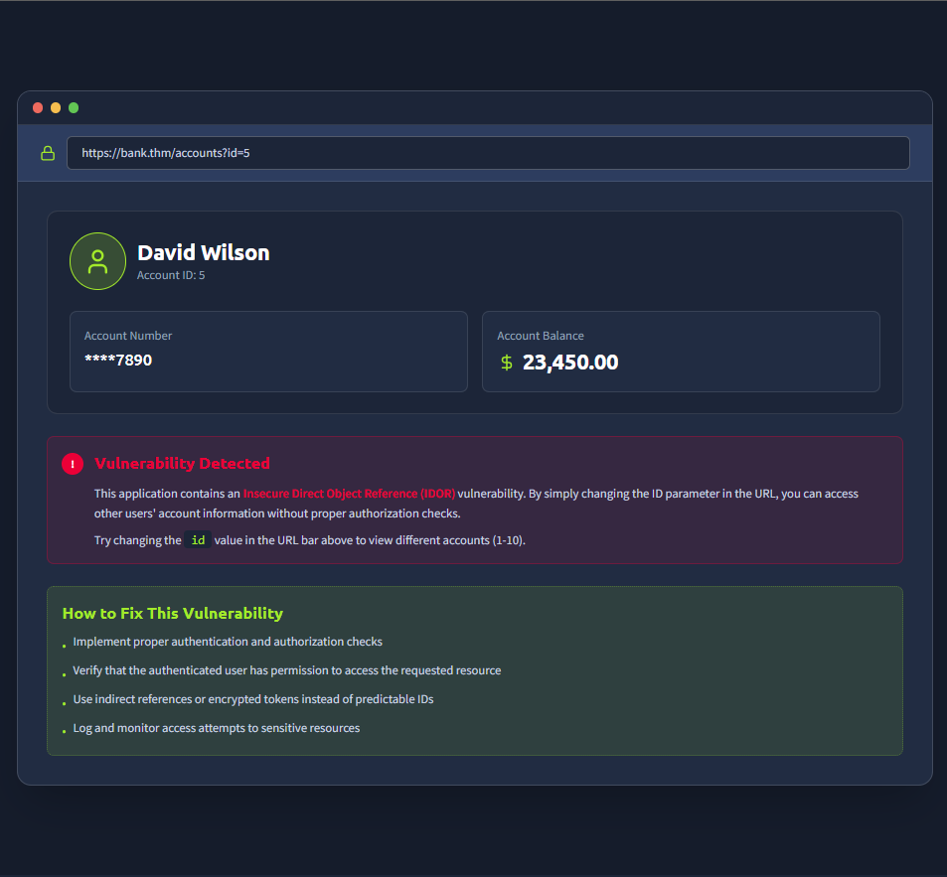
IDOR — accessing David Wilson's account (id=5) — vulnerability detected and remediation guidance shown

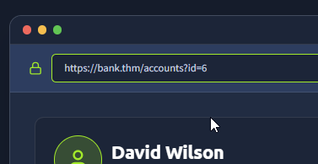
IDOR — URL manipulation to id=6 — different user's account accessed without authorisation

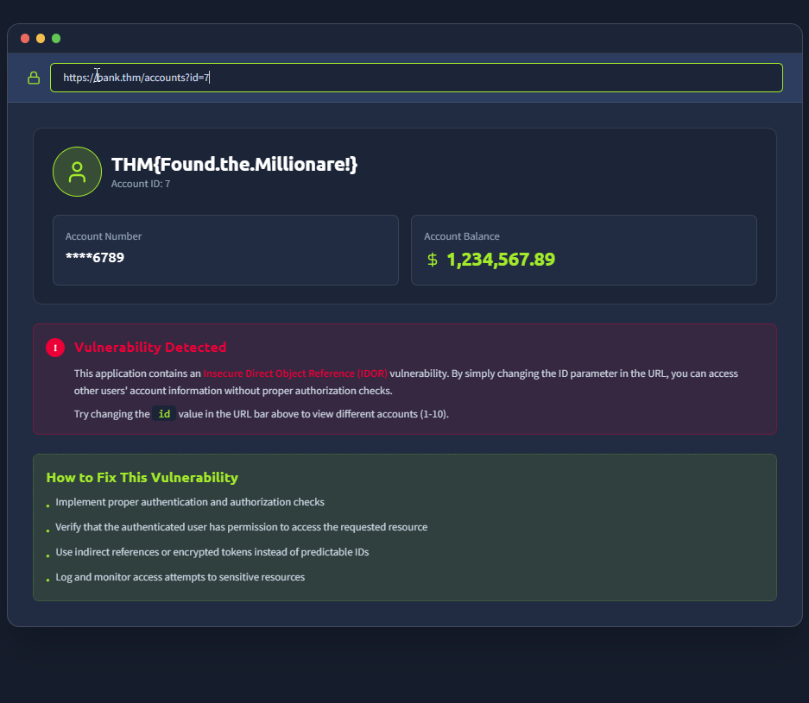
IDOR — continued account enumeration showing extent of exposure

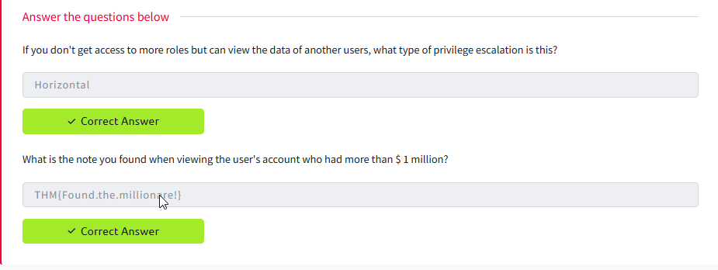
IDOR — additional account accessed confirming no server-side authorisation check

3.3 Mapping to IAM Controls
- This vulnerability is prevented in GlobalTech Corp's IAM configuration by:

  - RBAC enforcement
    - users can only access resources assigned to their role
    - Finance User role cannot access HR data and vice versa
  - Server-side authorisation
    - all resource access validated against the authenticated user's role and permissions
    - not just the request parameter
  - Audit logging
    - all access to sensitive resources logged to SIEM
    - enabling detection of enumeration attempts

4. Task 2 — Authentication Bypass and Credential Stuffing

4.1 Authentication Bypass
The Bank.THM login page at /login was tested for authentication weaknesses. The application was found to be vulnerable to credential stuffing — using a list of commonly used passwords against known usernames. The admin account was successfully compromised using the password 'Password123' after five failed attempts with weaker passwords.

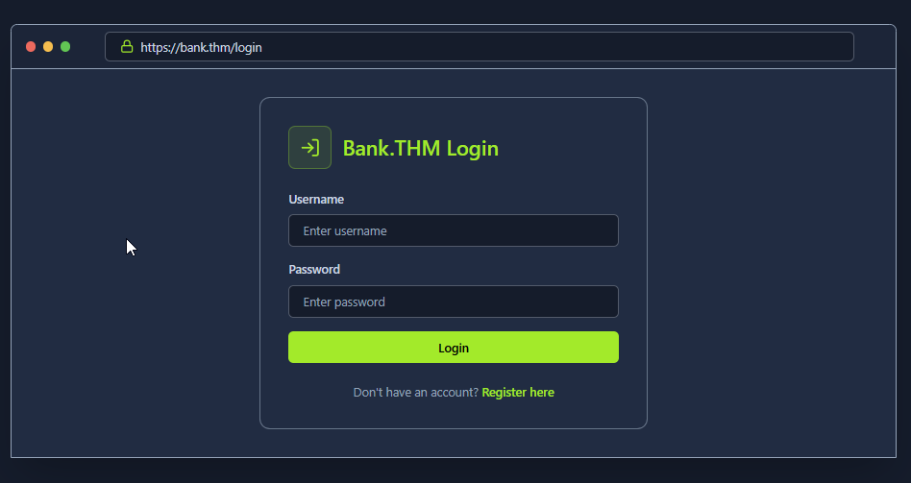
Bank.THM login page — starting point for authentication bypass testing

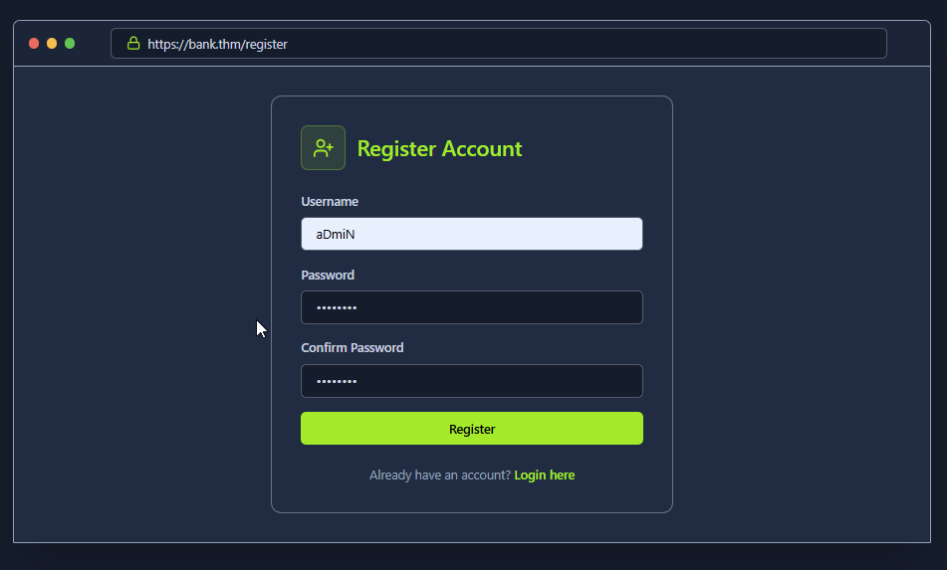
Authentication bypass — successful login as admin using credential stuffing

4.2 Admin Account Takeover
- Upon successful authentication as admin, the account dashboard revealed an account balance of $1,000,000.00 and the challenge flag THM{Account.confusion!FTW!} in the Account Description field.
- The admin username was confirmed as 'admin', which was accepted as the correct answer to the investigation question.

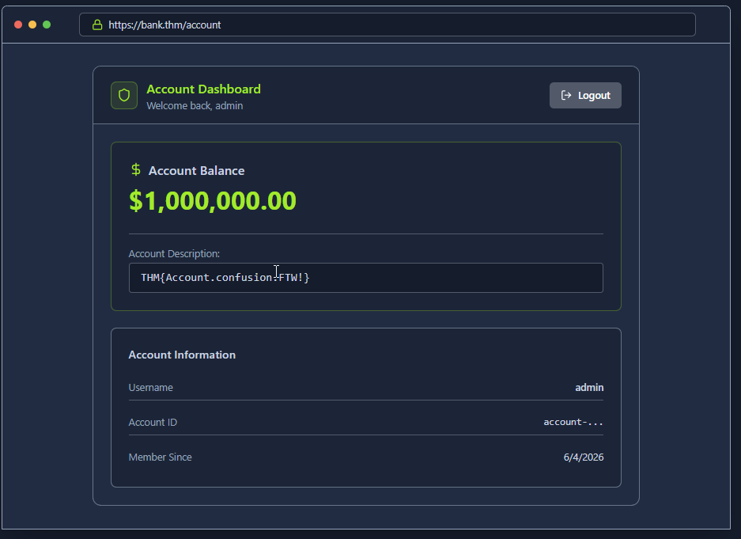
Admin account dashboard — successful takeover showing $1,000,000 balance and flag THM{Account.confusion!FTW!}

4.3 Mapping to IAM Controls
- This attack is prevented in GlobalTech Corp's IAM configuration by:

  - MFA mandatory for all accounts
    - even with correct credentials, the attacker cannot complete login without the second factor (TOTP or FIDO2 key)
  - Account lockout policy
    - 5 failed attempts triggers 30-minute lockout, preventing brute force and credential stuffing
  - Banned password list
    - 'Password123' and similar weak patterns are in the Entra ID banned password list and would be rejected at password creation
  - Admin FIDO2-only enforcement
    - conditional access policy requires hardware security key for admin accounts, making password-only attacks impossible

5. Task 3 : Access Log Analysis and Accountability

5.1 Credential Stuffing Attack in Logs
- The Bank.THM application server logs were analysed to identify the credential stuffing attack.
- The logs showed a sequence of 401 Unauthorized responses from IP 203.0.113.45 attempting common passwords against the admin account, followed by a 200 OK on the successful attempt with password 'Password123', and then an immediate access to the privileged endpoint /supersecretadminstuff.
- This log pattern : multiple rapid 401 failures from the same source IP followed by a 200 OK
  - is precisely the pattern detected by GlobalTech Corp's SIEM brute force alert rule (10+ failures from the same IP in 2 minutes triggers block and alert).

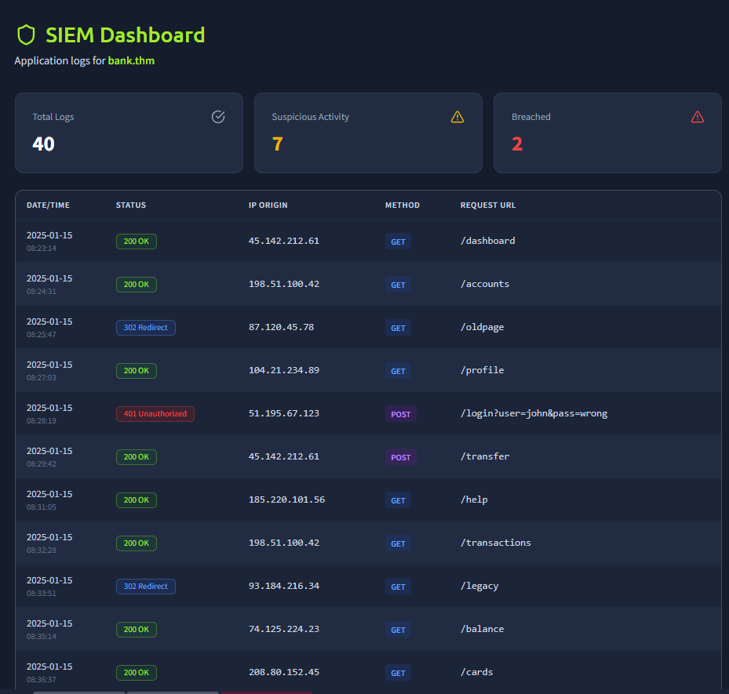
Server access logs — credential stuffing sequence from 203.0.113.45 showing 401 failures then 200 OK

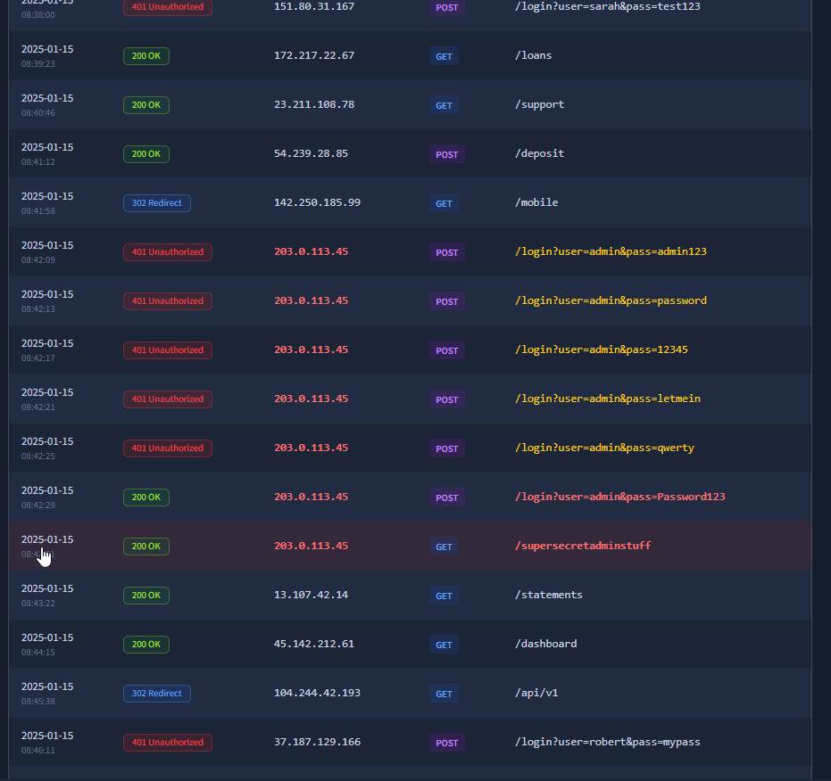
Server logs — continued attack sequence showing password enumeration pattern


Server logs — successful login (200 OK) with Password123 then immediate access to /supersecretadminstuff

5.2 Investigation Questions
- The lab presented a series of investigation questions based on log analysis. The following screenshots show the correct answers submitted:

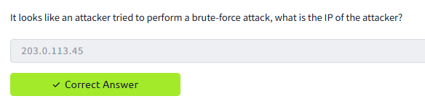
Investigation question — identifying the attacker IP address from logs

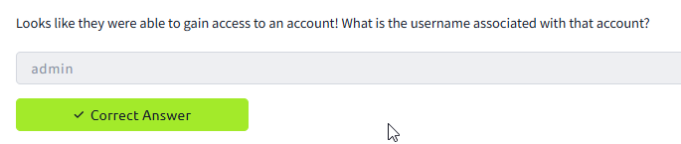
Investigation question — correct answer: admin (username accessed via brute force)

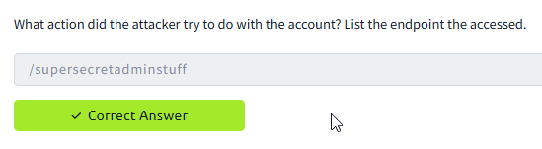
Investigation question — identifying the privileged endpoint accessed post-compromise


Investigation question — final investigation answer confirmed correct

5.3 Mapping to IAM Controls
- The accountability failures demonstrated in this task are addressed in GlobalTech Corp's IAM configuration by:

  - Centralised SIEM logging
    - all authentication events (success and failure) forwarded to Elastic SIEM with source IP, username, and timestamp
  - Brute force detection rule
    - SIEM triggers alert after 10 failed authentications from the same IP within 2 minutes
    - automatically blocking the source at the VPN gateway
  - PIM audit trail
    - all privileged access logged with justification, approver, and actions taken during session
  - Entra ID sign-in risk scoring
    - unusual access patterns (new IP, off-hours) trigger step-up authentication or block

6. Lab Completion
- The TryHackMe OWASP Top 10 2025: IAAA Failures room was completed in full
  - 6 tasks completed
  - 56 points earned by sawant052.

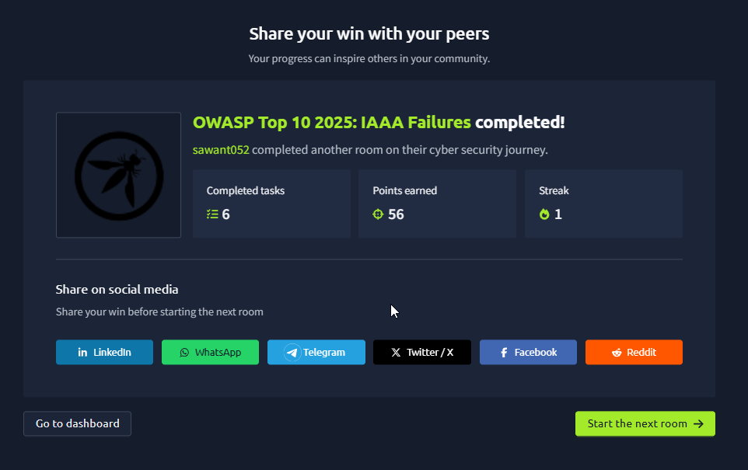
TryHackMe — OWASP Top 10 2025: IAAA Failures completed — 6 tasks, 56 points, user sawant052

7. Summary of Findings
- The following IAAA failures were identified and exploited during the lab:

  - IDOR
    - no server-side authorisation check on /accounts?id=N
      - all 10 user accounts accessible by any authenticated user
  - Credential stuffing
    - admin account compromised using common password 'Password123' after 5 failed attempts
      - no lockout or MFA in place
  - Broken authorisation
    - admin account granted access to privileged endpoint /supersecretadminstuff with no additional verification
  - Insufficient accountability
    - attack visible in logs but no automated detection or blocking
      - attacker completed full compromise unimpeded

8. IAM Configuration Validation
- Each finding directly validates a control in GlobalTech Corp's IAM Configuration:

Lab finding | Risk demonstrated | GlobalTech control
IDOR — account enumeration | Any user can access any account — full data exposure | RBAC + server-side authorisation + SIEM access logging
Credential stuffing — admin compromised | Full admin takeover with common password — no lockout | MFA mandatory + account lockout (5 attempts) + banned password list
Broken authorisation — privileged endpoint access | Admin accessed /supersecretadminstuff with no step-up auth | PIM just-in-time access — admin roles require approval + re-auth
No automated detection — attack unimpeded | Brute force visible in logs but no blocking triggered | SIEM brute force rule — blocks IP after 10 failures in 2 min, alerts security team

- The lab provides direct evidence that the IAM controls implemented for GlobalTech Corp
  - MFA, RBAC, account lockout, PIM, and SIEM alerting
    - collectively prevent the IAAA failure categories demonstrated in this exercise.

